Become a Friend of Citizens Advice Swale
Help us do even more to help people in our community find their feet and get their lives back on track. Becoming a Friend is personal involvement of the most important kind – because all the money you give will help to make a difference to lives in Swale.
- You’ll receive a FOCAS newsletter to keep you up to date with how we’ve helped Swale clients.
- You’ll have the satisfaction of knowing that you’re helping to make a difference to lives of local people.
- You’ll be invited to our AGM, where you can meet our staff in a friendly, informal atmosphere and feel part of the team.

How to pay/donate
Become a Friend for £30 per year per individual (donations above this rate are welcomed).
The Friend’s year begins the month following the AGM - annual subscriptions will usually fall in October.
Please complete your details and return this form to admin@citizensadviceswale.uk or Citizens Advice Swale, Swale House, East Street, Sittingbourne, ME10 3HT. Set up a Standing Order for Citizens Advice Bureau in Swale, Sort Code: 30-18-06, Account no: 00984174, Payment reference: Friends + your name. Alternatively send us a cheque made out to Citizens Advice Bureau in Swale.
Your name: ………………………………..…………………………………………………………….………
Email: ………………………………..……………………………………………………………………………..
Address: ……………………………………...………….…….....……..…………………………………...…
Postcode: …………….………...………….

Through the Government’s Gift Aid scheme, we can claim an additional 25p for every £1 you donate if you’re a UK taxpayer. We’ll use the details provided above to update your record and to process your donations to us. Gift Aid declaration: I am a UK taxpayer and would like Citizens Advice Swale to reclaim the tax on all donations I have made in the last four years and for all future gifts of money that I make to be Gift Aid donations.

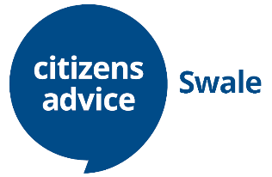
Signed: …………………………………………….. Date: …………………….…….…..

